08/07/2017

Project 2 – Design Phase

Name: Virti Bipin Sanghavi ID: 1001504428

Name: Dhinesh Kumar Sivakumaran ID: 1001393555

**Flow:**

Start 🡪Save input files as csv 🡪 Import data into tables using MySQL workbench 🡪 Execute script/program to create project and department document from MySQL and also insert it into MongoDB 🡪 Verify imported data using Queries 🡪Finish

**Data Import:**

**1)employee**

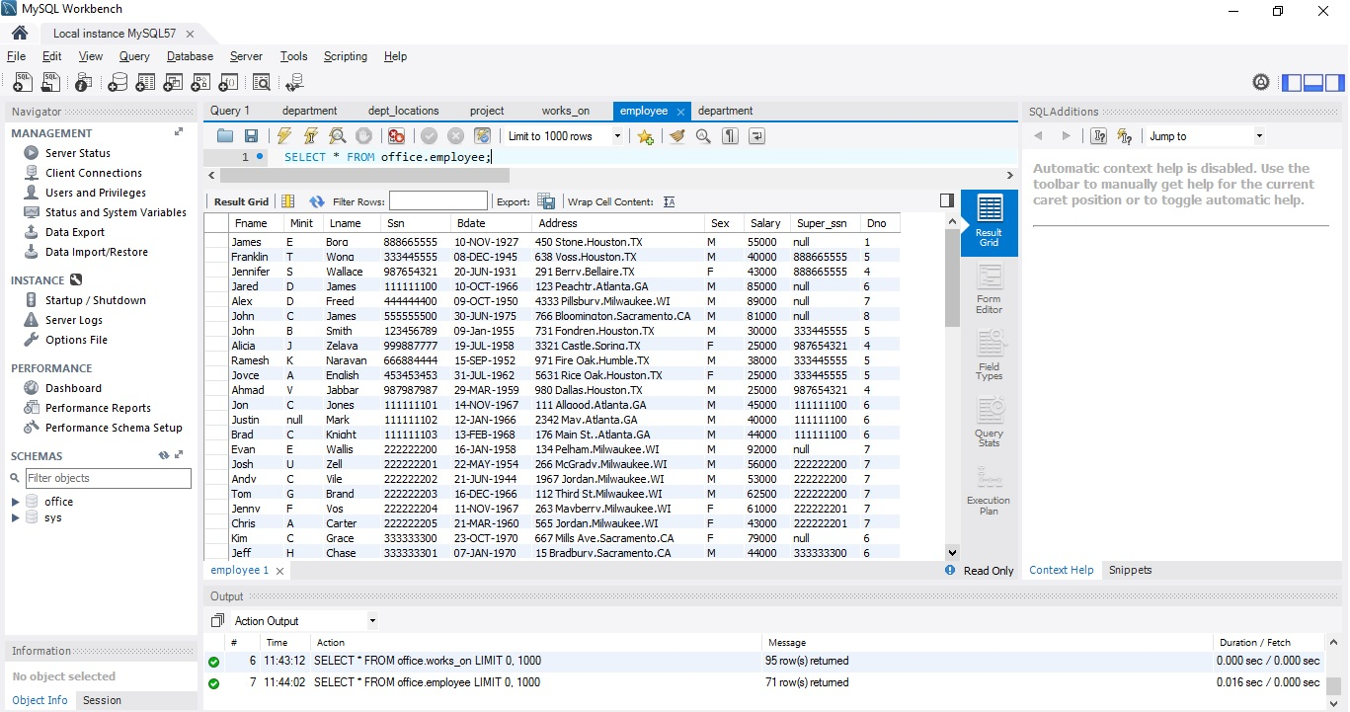

**2)department**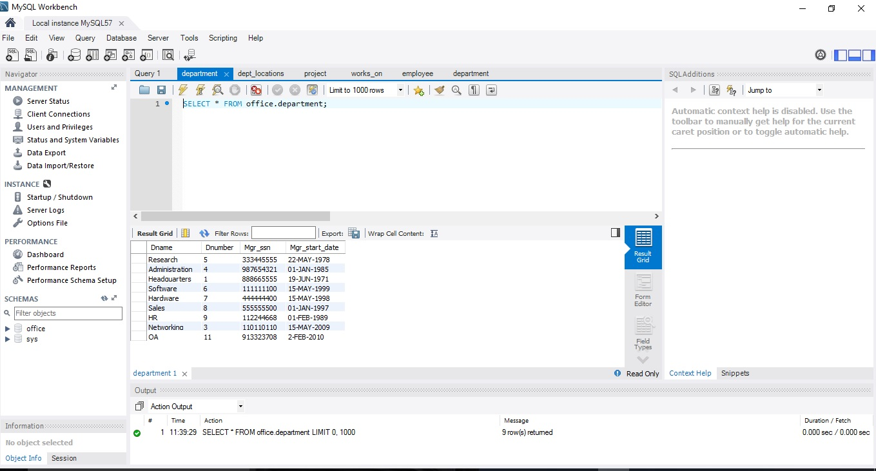

**3)works_on**

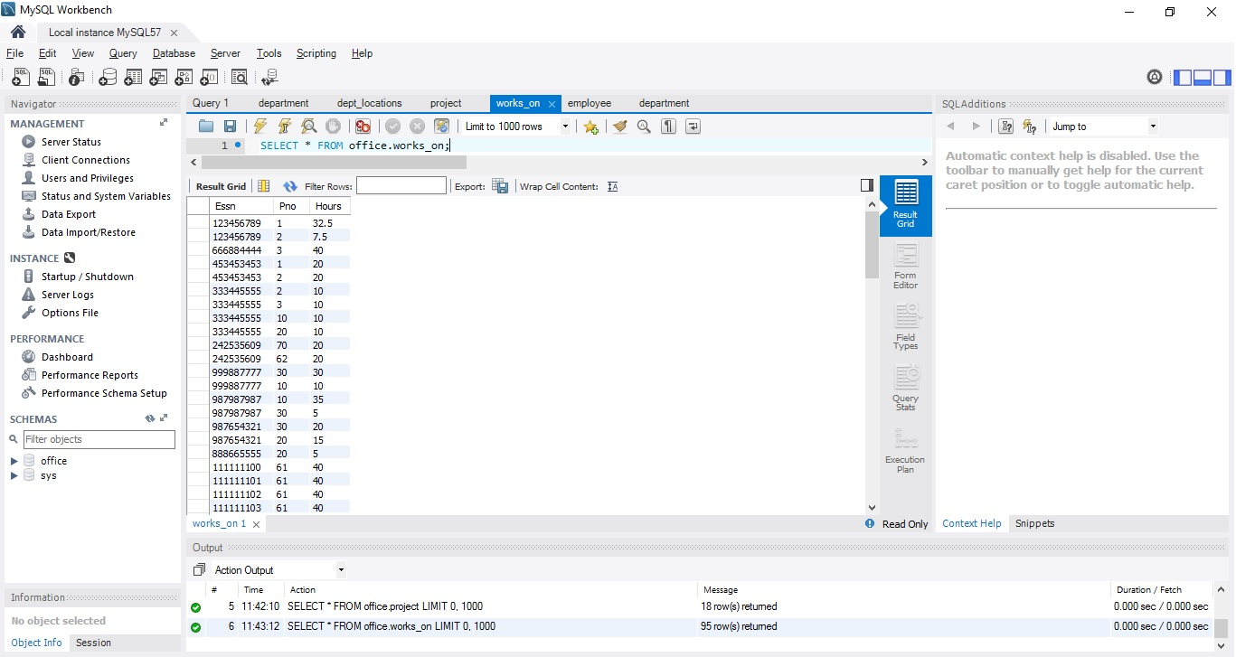

**4) dept_locations**

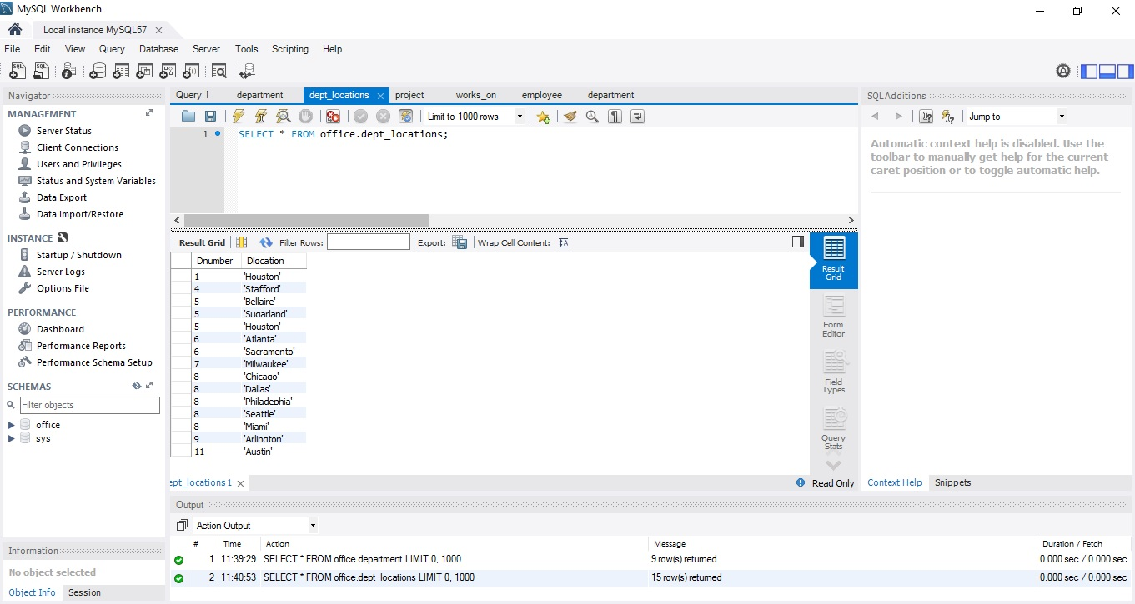

**5) project**

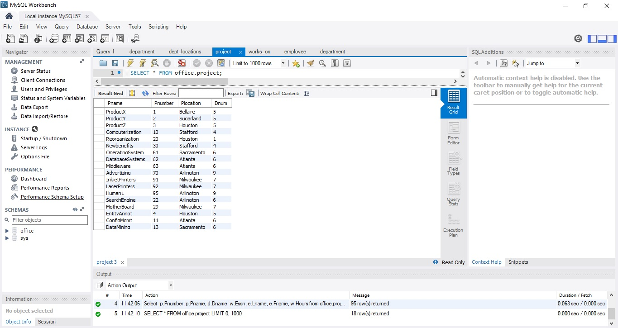

**Installation of MongoDB**

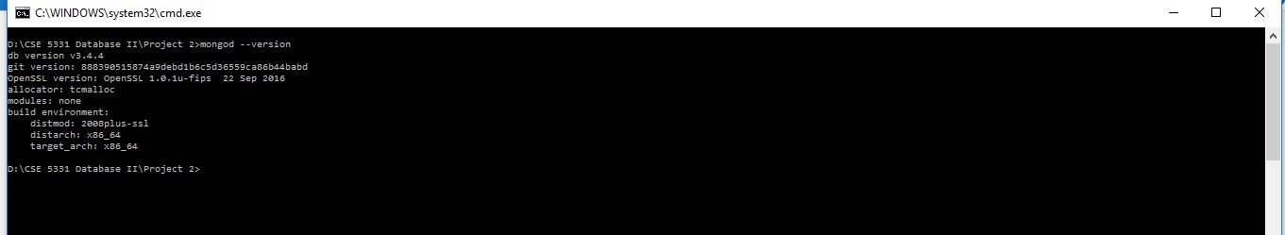

**MongoDB Server Started**

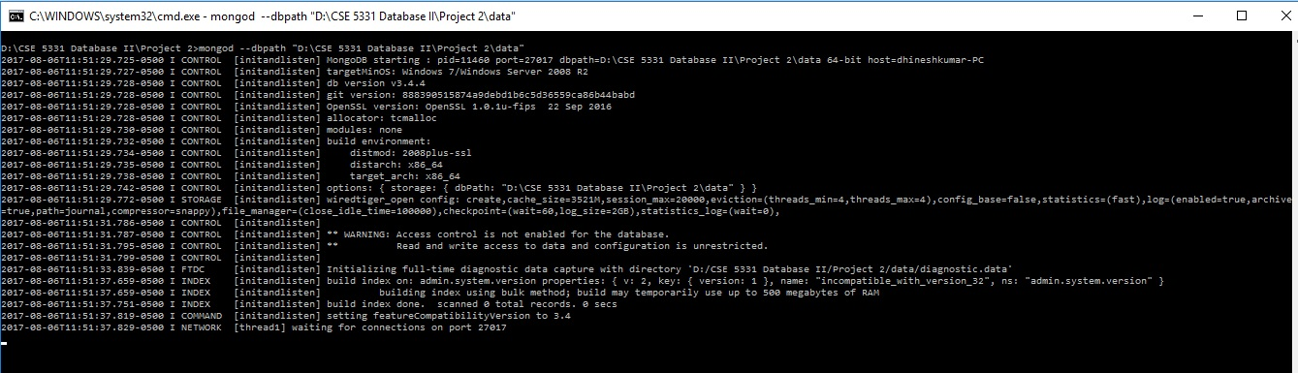

**Simple Document of MongoDB creation**

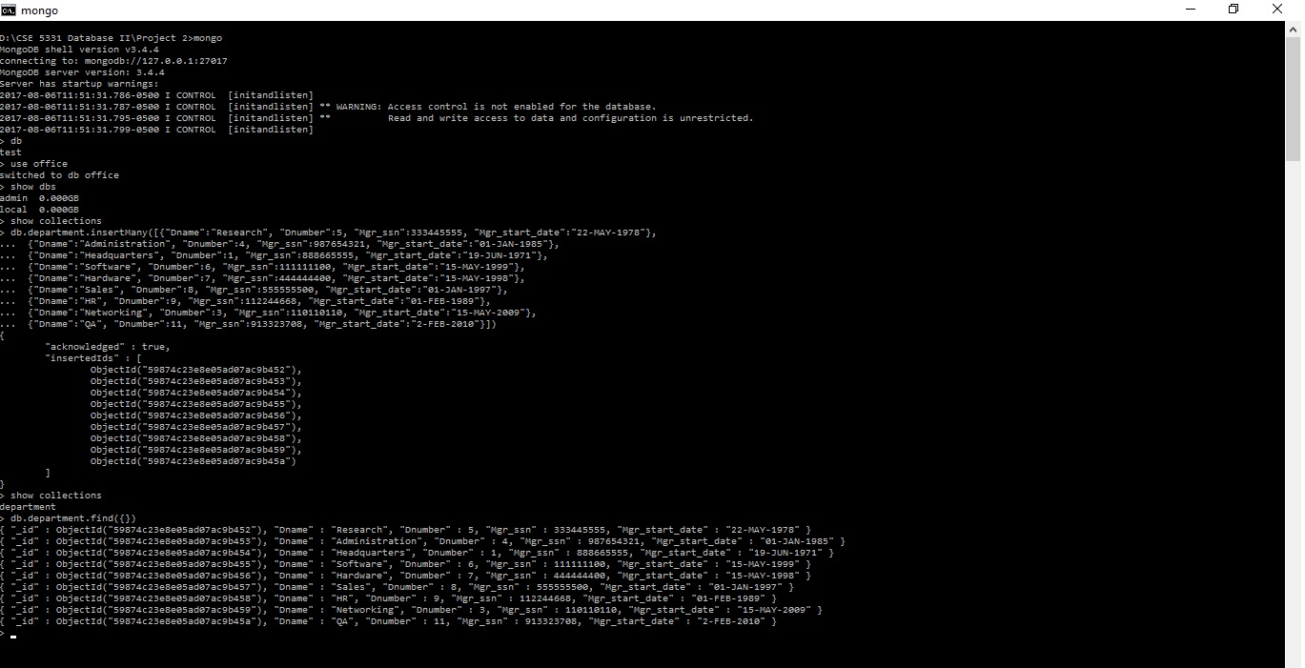

**How do you convert Relational Data into Mongodb?**

Project:-

Join project table with department to get department name and join it with works_on table to get employee (ssn,hours) working on each project and perform join with employee table based on ssn to get employee details (last name ,first name) order by project number.

Department:-

Join department table with employee table based on dept. manger ssn and employee ssn ,and Join it with department location based on dept. number then order by dept. name.**Pseudo Code**:

1.Connect to MySQL and Mongo DB

2.Execute query to retrieve department and project table

#In case of project data

*SELECT p.Pnumber, p.Pname, d.Dname, w.Essn, e.Lname, e.Fname, w.Hours*

*FROM (office.project as p INNER JOIN office.department as d on d.Dnumber = p.Dnum)*

*INNER JOIN (office.works_on as w INNER JOIN office.employee as e on e.Ssn = w.Essn) on w.Pno = p.Pnumber*

order by p.Pnumber;

#In case of department data

*SELECT d.Dname, e.Lname, l.Dlocation*

*FROM (office.department as d INNER JOIN office.employee as e on d.Mgr_ssn = e.Ssn)*

*INNER JOIN office.dept_locations as l on d.Dnumber = l.Dnumber*

*order by d.Dname;*

3.Loop thorough all result rows

#In case of project data

Group all records with same Pname, Pnumber, Dname and include their employees’ details as array of object with Essn, Fname, Lname attributes

#In case of department data

Group all records with same Dname, Manager Lname and include their location details as array of objects with Dlocation attributes.

4.Insert the output json object into mongo DB as Project and Department Document

5.Disconnect from MySQL and MongoDB

**Result for the Project Data:**

1. The PROJECT document will include the following data: Pnumber, Pname, Dname (of the controlling department), plus a list of the employees that work on the project {employees: Lname, Fname, Hours}.

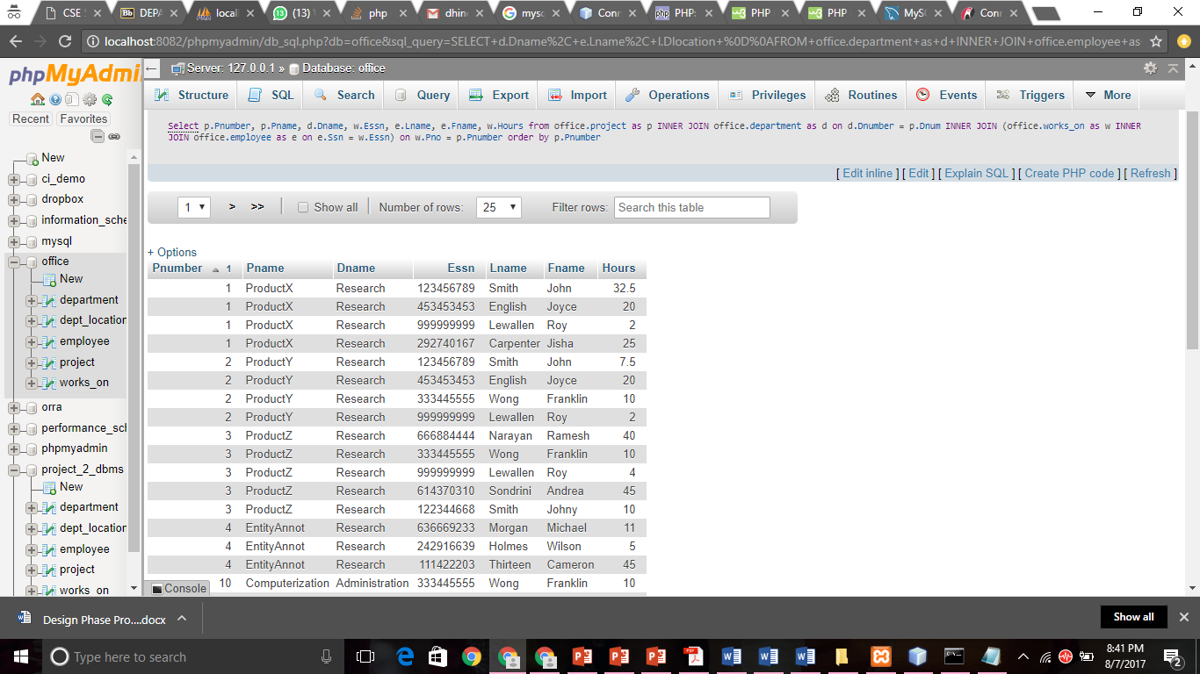

**Result for the Department Data:**

1. The DEPARTMENT document will include the following data: Dname, the department manager’s Lname, and a list of the locations of the department {locations: Dlocation}.

**Here we have been using grouping by attribute and group by Department name(Dname).**

Here, the department name stays constant, we make an array of the list of Last names of the manager of the department and the location he is working on.

